COIT11241: Cyber Security Technologies

Term 2, 2024

**Portfolio**

Name: Prabhu Ram Khadka, Sanjaya Poudel, Shaikh Sadik Rahman

ID: 12268198, 12240769, 12231823

Lecturer / Tutor: Tony Sahama  
Course Coordinator: Jamie Shield

Due Date: Sunday, 22-09-2024, 11:59 PM

Week 6

Screenshot 1: Display the confirmation of running Nessus.

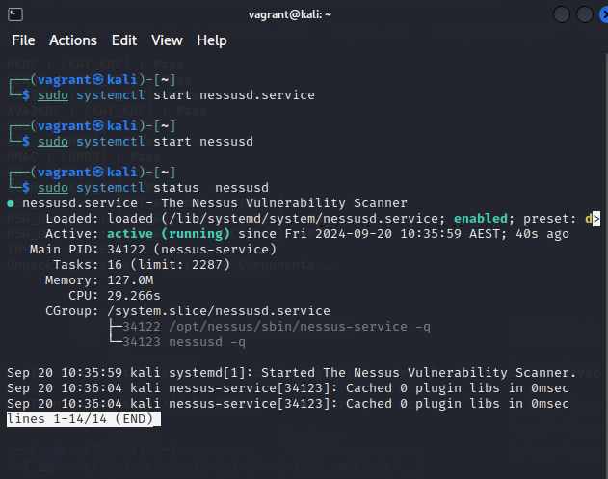

Screenshot 1

Following steps should be done to reach up to above picture:

Step 1: open browser and download Nessus lates version.

Step 2: one Treminal Emulator in Nessus and write following code:

sudo dpkg -i Nessus-<version>.deb

sudo systemctl start nessusd.service

Screenshot 2: Show the starting point of Nessus.

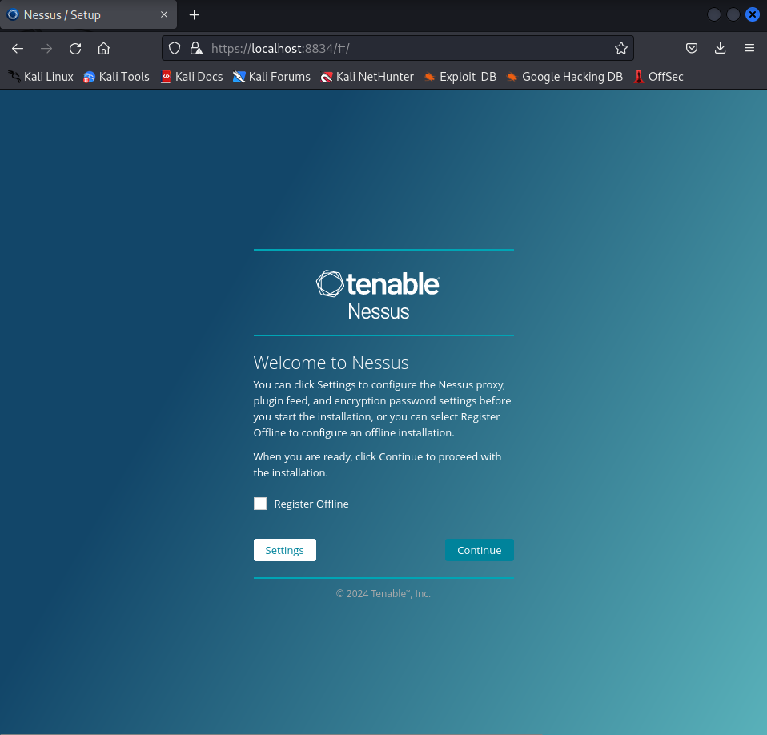

Screenshot 2

After this we need to register Nessus.

Screenshot 3: Illustrate the installing phase of Nessus.

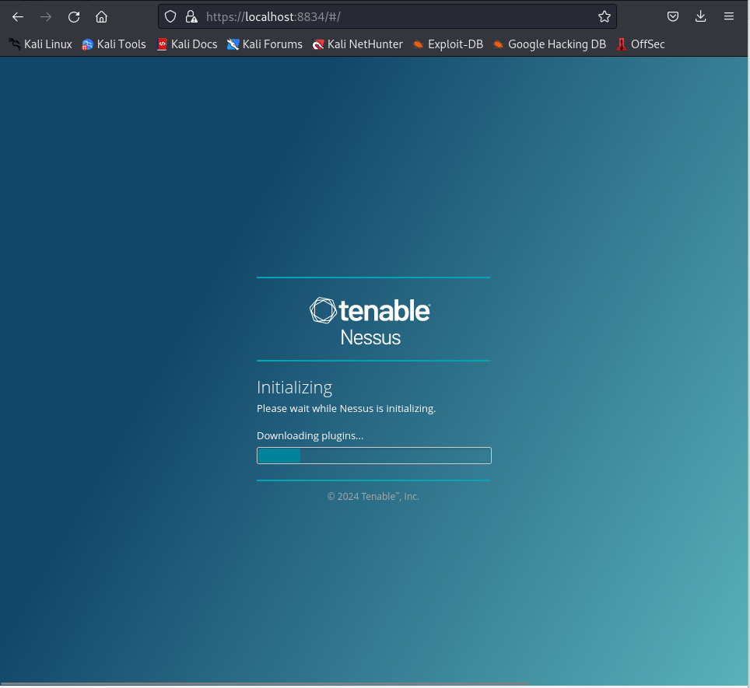

Screenshot 3

Screenshot 4: Display the Home page of Nessus.

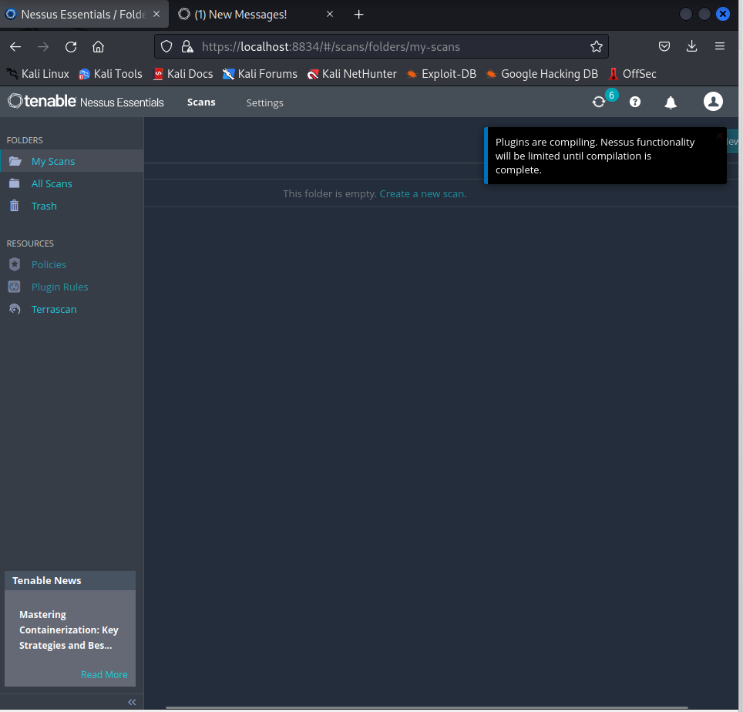

Screenshot 4

Screenshot 5: Display the cerating new scan.

Screenshot 5

What is vulnerability?

A weakness in an IT system that can be exploited by an attacker to deliver a successful attack is known as vulnerability. They can occur through flaws, features or user error, and attackers will look to exploit any of them, often combining one or more, to achieve their end goal.

What is vulnerability scan?

The process of discovering, analyzing, and reporting on security flaws and vulnerabilities is called vulnerability. Vulnerability scans are conducted via automated vulnerability scanning tools to identify potential risk exposures and attack vectors across an organization's networks, hardware, software, and systems.

Advantage of vulnerability scan?

The vulnerability scanning is important because it helps organizations reduce cyber risk by identifying and fixing vulnerabilities before attackers can exploit them.

Screenshot 6:Display the Host with its vulnerabilities.

Screenshot 6

Screenshot 7: Shows the histoyr of vulnerability scan.

Screenshot 7

Type of vulnerability risk

There are four type of vulnerability risk they are:

1. Critical

Critical vulnerabilities usually have a high likelihood of being exploited and the potential to allow an attacker to cause extensive damage or fully compromise the affected system.

1. High

Security vulnerabilities are classified as high risk if it satisfies either one of the following conditions. Typically used by security vulnerabilities which may cause low or medium impact on the target systems. At the time of disclosure, the vulnerabilities are actively exploited in the wild.

1. Medium

Typically used by security vulnerabilities which may cause low impact on the target systems. At the time of disclosure, the security vulnerabilities satisfy either one of the following situations: Attack code is publicly available; or. The vulnerabilities are being used in scattered exploit.

1. Low

Vulnerabilities in the low range typically have very little impact on an organization's business. Exploitation of such vulnerabilities usually requires local or physical system access.

Screenshot 8 & 9 : Illustrate the Vulnerabilities.

Screenshot 8

Screenshot 9

Screenshot 10, 11: Show the example of low risk vulnerability.

Screenshot 10

Screenshot 11

Screenshot 12, 13: Show the example of critical risk vulnerability.

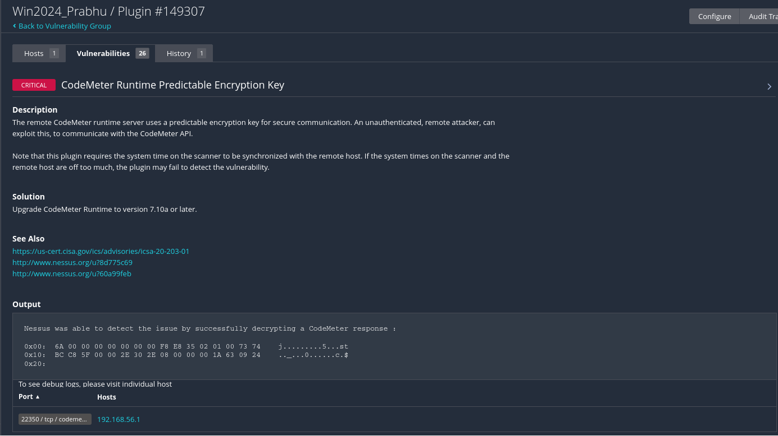

Screenshot 12

Screenshot 13

Screenshot 14, 15 : Show the example of medium risk vulnerability.

Screenshot 15

What is informational vulnerability?

Informational vulnerabilities are vulnerabilities that provide specific bits of information to the end-user that were not designed to be released, yet have no specific security impact on the application, host, or environment.

Screenshot 16: Show the example of medium risk vulnerability.

Screenshot 16

Reference

Kidd, C. (2022). *Security 101: Vulnerabilities, Threats & Risk Explained*. [online] Splunk-Blogs. Available at: <https://www.splunk.com/en_us/blog/learn/vulnerability-vs-threat-vs-risk.html>.

Tunggal, A.T. (2023). *What is a Vulnerability?* [online] Upguard.com. Available at: https://www.upguard.com/blog/vulnerability.